Introduction:

An arithmetic logic unit (ALU) is a combinational digital circuit used to perform arithmetic and logic operations. It performs bitwise operations on integer binary numbers. It represents the fundamental building block of the central processing unit (CPU) of a computer. Modern CPUs contain very powerful and complex ALUs. In additions to ALUs, modern CPUs contain a control unit (CU)
The purpose of ALU is to perform mathematical operations such as addition, subtraction, multiplication and division. ALU comprises two main units. Arithmetic Unit and Logic Unit.
The arithmetic operations are like addition, subtraction, increment, decrement, transfer and logical operations are like NOT, OR, XOR, AND etc.
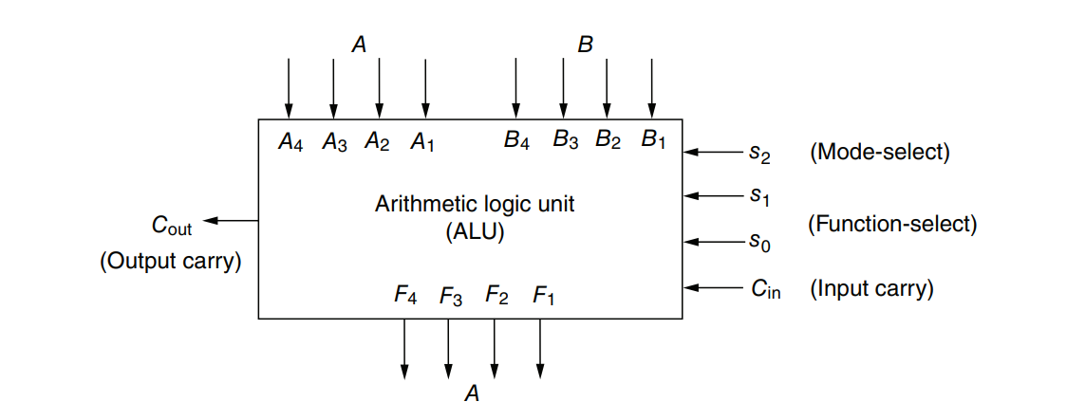
Figure 1: Block diagram of a 4-bit ALU

Problem Specification with assigned instructions:

Design a 4-bit ALU equipped with a 4-bit flag output with three selection bits cs0, cs1, cs2. The ALU is designed to handle two 4-bits input numbers A, B

Control Signals |  |  | Functions | Modified Inputs
CS2 | CS1 | CS0 |  | Xi | Yi | Z₀
0 | 0 | 0 | Decrement A | Ai | 1 | 0
0 | 0 | 1 | Neg A | Ai’ | 0 | 1
x | 1 | 0 | OR | Ai OR Bi | 0 | 0
0 | 1 | 1 | Subtract with borrow | Ai | Bi’ | 0
1 | 0 | x | Subtract | Ai | Bi’ | 1
1 | 1 | 1 | Complement A | Ai’ | 0 | 0

ALU also implements the following four flags which will be affected as per the rules of Assembly Language.

Flag Code | Name | Description
CF | Carry | Indicates an unsigned overflow scenario
ZF | Zero | When the result is zero then it set to 1
VF | Overflow | When sign overflow condition happens
SF | Sign | Represents the sign of the result

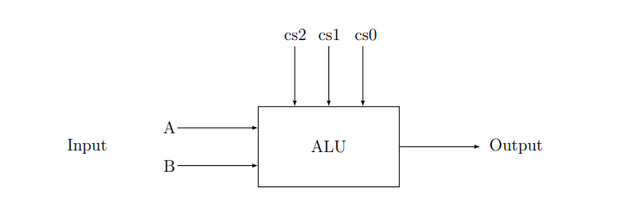
Figure 2: 4-bit ALU input output

Detailed Design Steps with K-maps:

K-Maps:
For Xi:
CS0  CS2 CS1 | 0 | 1
00 | Ai | Ai’
01 | Ai + Bi | Ai
11 | Ai + Bi | Ai’
10 | Ai | Ai

Using decoders with active low output:
Xi = Ai (D₀ + D₃ + D₄ + D₅) + (Ai + Bi) (D₂ + D₆) + Ai’ (D₁ + D₇)
= Ai (D₀ + D₂ + D₃ + D₄ + D₅ + D₆) + Ai (D₁ + D₇) + Bi (D₂ + D₆)
= Ai (D₁’ D₇’) + Ai’ (D₁’ D₇’)’ + Bi (D₂’ D₆’)’
= Ai Ꚛ(D₁’ D₇’)’ + Bi (D₂’ D₆’)’
For Yi:
CS0  CS2 CS1 | 0 | 1
00 | 1 | 0
01 | 0 | Bi’
11 | 0 | 0
10 | Bi’ | Bi’

Yi = D₀ + Bi (D₃ + D₄ + D₅)
= (D₀’)’ + Bi (D₃’ D₄’ D₆’)’
= (D₀’)’ + (Bi + (D₃’ D₄’ D₆’))’
For Zi
CS0  CS2 CS1 | 0 | 1
00 | 0 | 1
01 | 0 | 0
11 | 0 | 0
10 | 1 | 1

Z0 = D₁ + D₄ + D₅
= (D₁’ D₄’ D₆’)’

Truth-Table:

Control Signals |  |  | Functions | Modified Inputs
CS2 | CS1 | CS0 |  | Xi | Yi | Z₀
0 | 0 | 0 | Decrement A | Ai | 1 | 0
0 | 0 | 1 | Neg A | Ai’ | 0 | 1
0 | 1 | 0 | OR | Ai OR Bi | 0 | 0
1 | 1 | 0 | OR | Ai OR Bi | 0 | 0
0 | 1 | 1 | Subtract with borrow | Ai | Bi’ | 0
1 | 0 | 0 | Subtract | Ai | Bi’ | 1
1 | 0 | 1 | Subtract | Ai | Bi’ | 1
1 | 1 | 1 | Complement A | Ai’ | 0 | 0

Block Diagram:
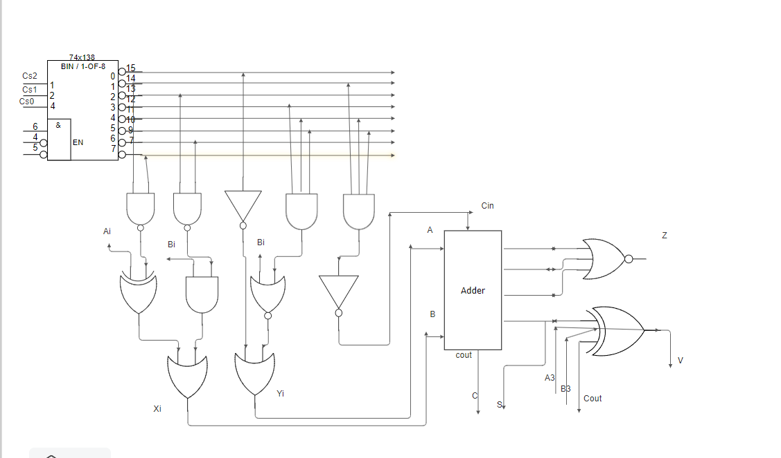
Figure: Block Diagram
ICs used with count as a chart:
IC with Code | Quantity
IC 74138 | 1
IC 7408 | 2
IC 7400 | 1
IC 7402 | 1
IC 7486 | 2
IC 7483 | 1
IC 7432 | 3
TOTAL | 11
Table : ICs used with quantity

Discussion:
In this assignment we were asked to implement a 4-bit ALU which performs 6 operations with the minimum numbers of ICs.

